Specimen Type | Appropriate Specimens | Container
Body Fluids  - Ascitic  - Pleural  - Pericardial  - Peritoneal  - Pancreatic Cyst Fluids  - Ovarian Cyst Fluids  PLEASE NOTE THAT CELL COUNTS ARE NO LONGER PERFORMED | - Please send in at least 25ml of fluid – 50ml if possible. | 25 ml sterile universal container  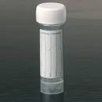
Breast Cyst Fluid | Send only if blood stained | 25 ml sterile universal container
Breast Fine Needle Aspirates | - Prepare two fixed slides as directed by laboratory personnel  - Rinse needle in preservcyt solution  *If not trained in slide spreading, please just send in needle rinse* | Slides must be labelled in pencil with name and date of birth/unit number  Needle Wash  10 ml preservcyt in 25 ml sterile universal container
Bronchial Brushes | - Brush is sent to laboratory  PLEASE DO NOT PREPARE SLIDES | Vial of 10ml cytorich red  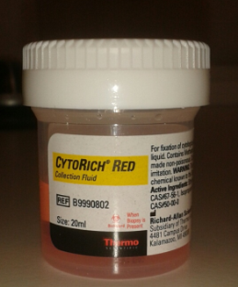
Bronchial Washes | - Add wash to universal and top up with cytorich red – ensure at least 50% of fluid is cytorich red. | 25 ml sterile universal container containing cytorich red
Bronchoalveolar Lavage | - Add wash to small universal and send immediately –  *Please state on form whether the identification of fat-laden or haemosiderin-laden macrophages is required* | 25ml sterile universal container
CSF | - Please send to laboratory immediately after taking specimen  - If the specimen is taken outside of normal laboratory hours the specimen must be refrigerated | Small glass vial or 25ml sterile universal container
Fine Needle Aspirates | - Prepare one fixed and one air-dried  slide as directed by laboratory personnel  - For Thyroid specimens, rinse needle in phosphate buffered saline  - All others rinse needle in preservcyt solution | Slides must be labelled in pencil with name and date of birth/unit number  Needle Wash  10 ml preservcyt or phosphate buffered saline in 25 ml sterile universal container
Gastrointestinal Tract material | - Brush is sent to laboratory  PLEASE DO NOT PREPARE SLIDES | 10 ml of phosphate buffered saline OR cytorich red in 25 ml sterile universal container
Pancreatic FNA | - Rinse needle in cytorich red | Vial of 10ml cytorich red or 10ml cytorich red in sterile universal container
Sputum | - Deep cough early in the morning prior to brushing teeth or eating breakfast  - Specimens should be taken on 3 consecutive days. | Sputum pot  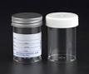
*PLEASE NOTE: Sputum specimens should not be sent for the diagnosis of PCPs*

Urine | - Freshly voided specimen preferably mid-morning  - Avoid early morning urine as the cells will appear degenerate and interpretation will be difficult/non diagnostic  - Avoid catheter specimens  - If catheter specimen cannot be avoided, please note on request form | 25 ml sterile universal container

